# 2. Contact List

**Environment Specifics**

Please be aware that every JS environment may **behave differently** when executing code. Certain things that work in the browser are not supported in **Node.js**, which is the environment used by **Judge**.

The following actions are **NOT** supported:

* **.forEach()** with **NodeList** (returned by **querySelector()** and **querySelectorAll()**)
* **.forEach()** with **HTMLCollection** (returned by **getElementsByClassName()** and **element.children**)
* using the **spread-operator** (**...**) to convert a **NodeList** into an array
* **append()** (use only **appendChild()**)
* **prepend()**
* **replaceWith()**
* **replaceAll()**
* **closest()**
* **replaceChildren()**

If you want to perform these operations, you may use **Array.from()** to first convert the collection into an array.

**Use the provided skeleton to solve this problem.**

**Note**: You **can't** and you have no permission to **change** directly the given HTML code (index.html file).

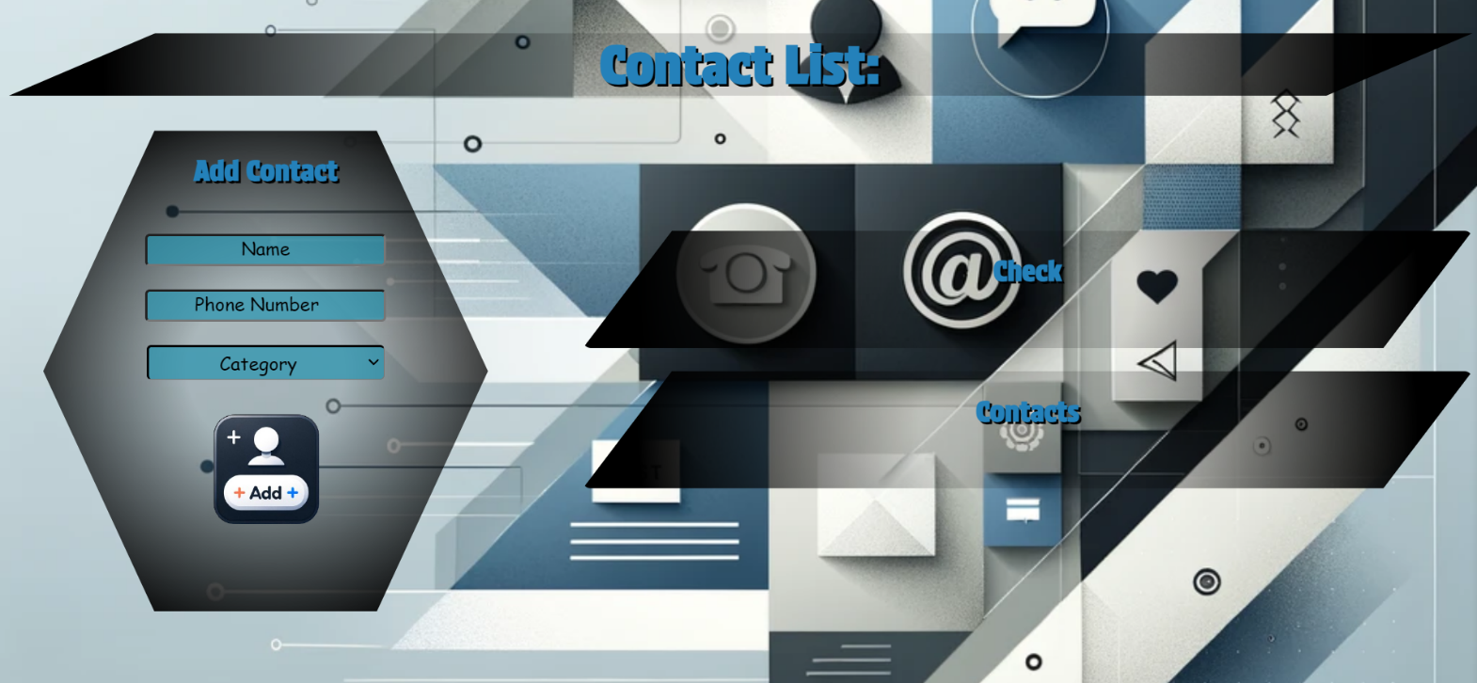

# Your Task

**Write the missing JavaScript code** to make the **Contact List** work as expected:

* + **Name, Phone Number,** and **Category** should be **non**-**empty** **strings**. If any of them are empty, the program should not do anything.

# 1.Getting the information from the form

When you click the **[Add]** button, the information from the input fields must be added to the <ul> with the id "check-list"and the input fields should be **cleared**.

The HTML structure should look like this:

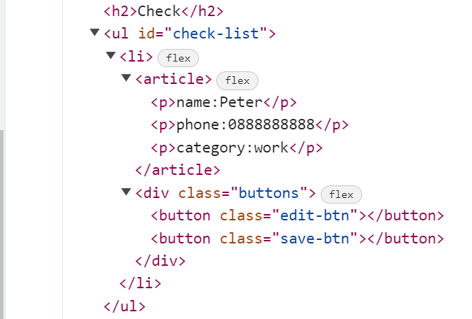

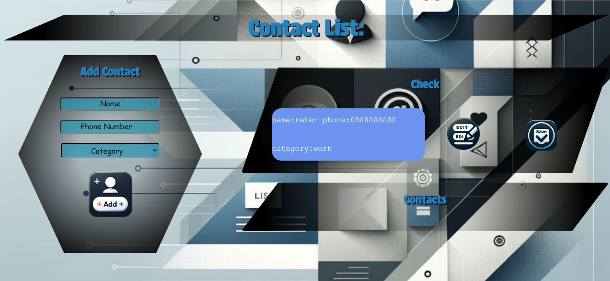

# 2.Edit Contact

When the **[Edit]** button is clicked, the information from the check must be sent to the input fields on the left side and the record should be deleted from the <ul> "check-list".

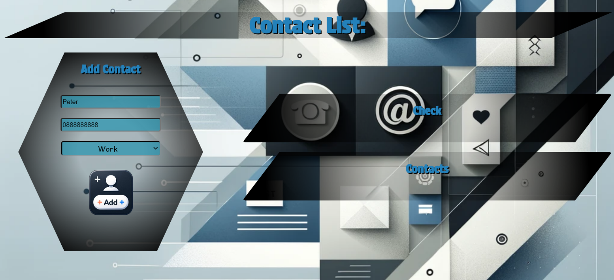

After editing the information, add a new item to the <ul> with the updated information.

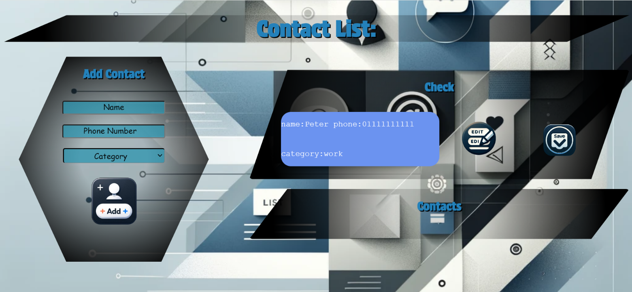

# 3.Save Contact

When you click the **[Save]** button, the task must be **deleted** from the <ul>withid"check-list" and appended to the <ul> with id "contact-list".

The **buttons [Edit]** and **[Save]** should be removed from the <li> element and the **button [Delete]** shoud be added.

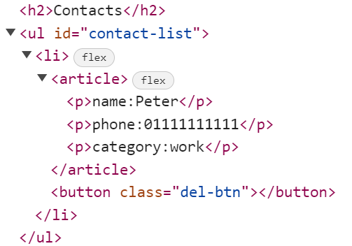 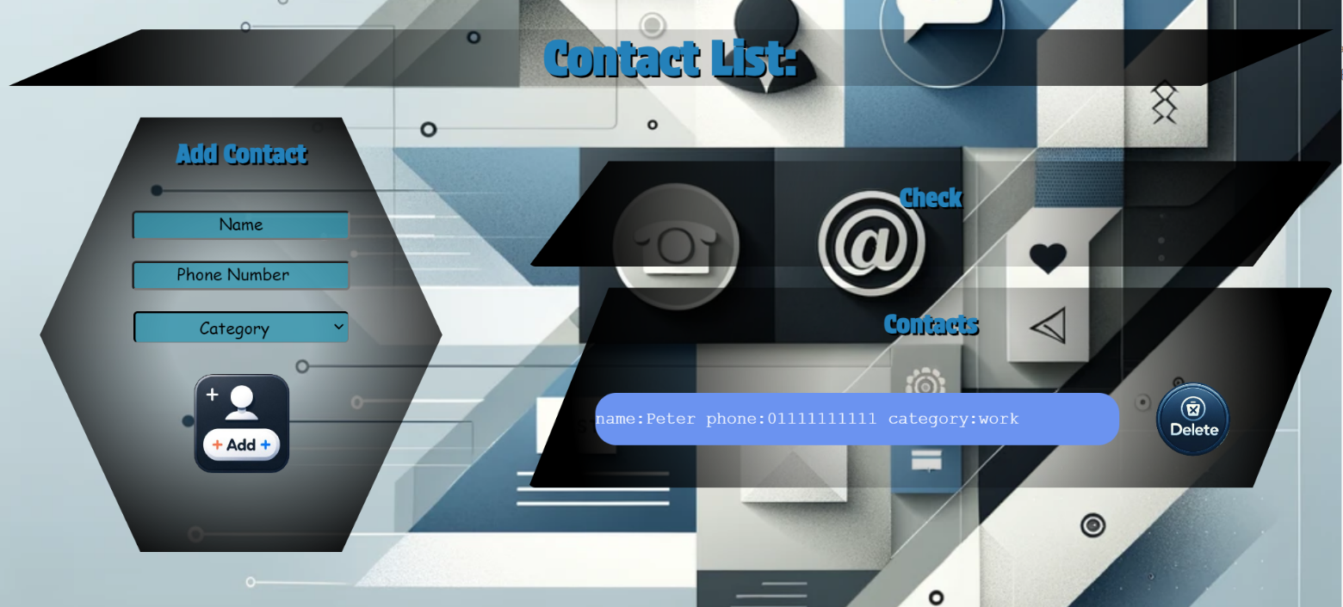

# 4.Delete Contact

When you click the **[Delete]** button, the task must be **deleted** from the <ul>withid"contact-list" .

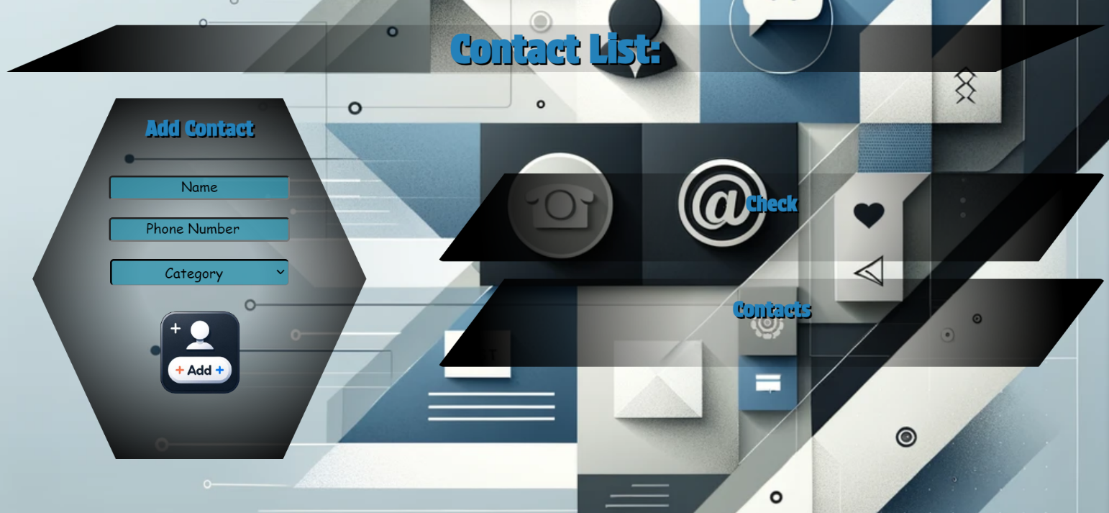

# Submission

Submit only your **solve()** function.